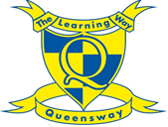
Home learning for Reception – Owl and Dove class.
Week Beginning: Monday 15th June 2020
*Please remember you can upload photos of children’s learning to their 2Simple learning journals by replying to one of the emails you have received with your child’s observations from school. It would be lovely to see what the children have been busy learning at home.
Phonics:
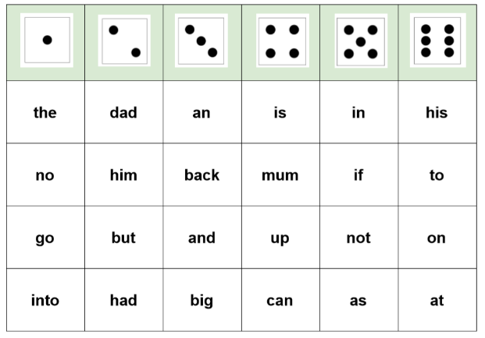
Phase Two Read and Roll Game:

Roll the dice…. whichever number it lands on, choose one word from the correct column and read it from sight. Once you have read it, cross the word off your grid. Keep rolling the dice until you have crossed all the words off your grid.

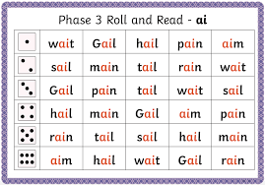
Phase Three Read and Roll Game:

Roll the dice…. whichever number it lands on, choose one word from the correct column and read it from sight. Once you have read it, cross the word off your grid. Keep rolling the dice until you have crossed all the words off your grid.

Challenge: Can you make your own read and roll game? Choose one phoneme (sound) and see how many words you can think of with the same sound. Make your own grid and have a go with someone at home.


Reading:

This week in English, we are going to be reading the story, ‘Planting a Rainbow’. For your reading activity we would like you to play a game of I-spy in your garden, or in an outside area of your choice. In the book, there are lots of different beautiful flowers and plants that are each, different colours. Look around your outside space and see if you can spot any wonderful colours or plants. Use these to play your game of I-spy.

Challenge: Can you have a go at writing down some things that you have spotted in your outside space? Think very carefully about the first sound that you hear. You can also use your segmenting and blending to help you spell the word.

Read to your child
Learning to read can be hard work for many children, so it is important to keep enjoying books together. Your child will also benefit from listening to books and stories that they cannot read themselves yet. This might include non-fiction books about things they are interested in or longer stories with more adventurous vocabulary.

Make sure that you continue to read with your child every night. Bedtime stories are such a special routine to have in place, so make the most of this time with your child.

English:
This week we will be looking at the story, ‘Planting a Rainbow’. Click on the link below to listen to the story:

https://www.youtube.com/watch?v=LkQByrv_m5o

After you have listened to the story, have a discussion with someone at home and think about these questions.

What would your perfect garden look like?
What colours would you have in your garden?
Can you name any plants that you would plant in your garden?

Have a go at drawing a picture of your very own rainbow garden. Think very carefully about which colours you are going to use and which flowers you would like to draw. You can use the pictures from the book to help you. For an extra challenge, see if you can label any of the colours or plants in your picture.

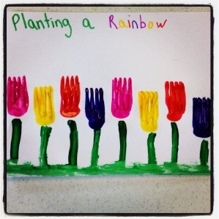
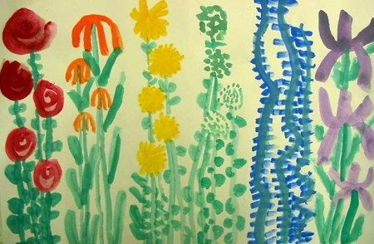

Challenge: Use look cover write check to practice spelling colours - red, purple, orange, yellow, green, blue, pink.

Maths:
This week, we are going to be looking at shapes. Watch the video below to refresh your knowledge of 2D shapes- Can you remember the names of any 2D shapes before you watch the video?

https://www.bbc.co.uk/bitesize/clips/zhnvcdm

Think about the shapes that you have seen in the video; can you think of any other shapes? Use the shapes that you have seen, or already know, to help you create a picture. Here are some examples of the types of pictures you could make using the 2D shapes.
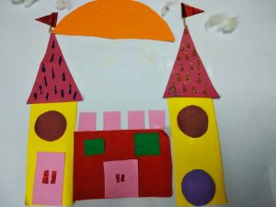
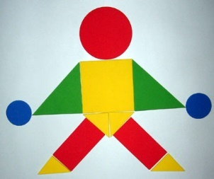
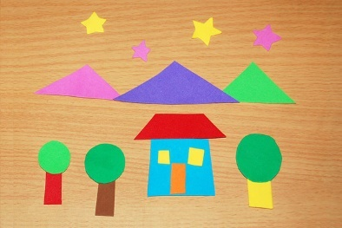

Challenge: Can you write a list of the shapes you have used? For an extra challenge, can you remember how many sides this shape has?

PE/Active lesson

Have a go at this cosmic Yoga session… Can you flap your wings like a butterfly?

https://www.youtube.com/watch?v=pT-s1-phgxs

You could also try, Andy’s Wild Workout… How many mini beasts will you find?

https://www.youtube.com/watch?v=mCFDa1PcyZU

Family Fun:
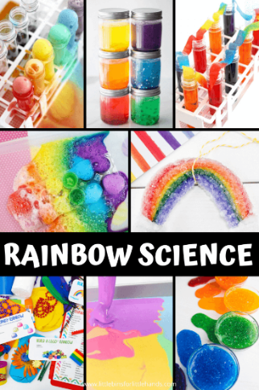
See if you can have a go at this science experiment with somebody at home…

You will need:

- Skittles/food colouring
- Water
- White plate

Method:

- Set out a bowl of skittles but ask somebody to help you.
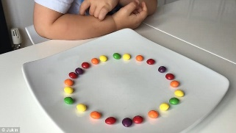
- Arrange them in the rainbow pattern around the edge of a plate, alternating colours. Which colours will you use?
- Before you pour in the water, what do you think might happen?
- Carefully pour the water into the centre of the plate until it just covers the skittles. Be careful not to shake or move the plate once you add the water or it will affect the results.

Did you create your rainbow? Can you take a picture of it to show us?

E safety information:
10 top tips for staying safe on the internet:
1) Don’t post any personal information online – like your full name, email address, mobile number, etc.
2) Think carefully before posting pictures or videos of yourself. Once you’ve put a picture of yourself online, most people can see it and may be able to download it, it’s not just yours anymore.
3) Keep your privacy settings as high as possible!
4) Never give out your passwords.
5) Don’t befriend people you don’t know.
6) Don’t meet up with people you’ve met online. Speak to your parent or carer about people suggesting you do.
7) Remember that not everyone online is who they say they are.
8) Think carefully about what you say before you post something online.
9) Respect other people’s views, even if you don’t agree with someone else’s views doesn’t mean you need to be rude.
10) If you see something online that makes you feel uncomfortable, unsafe or worried: leave the website, turn off your computer if you want to and tell a trusted adult immediately.

